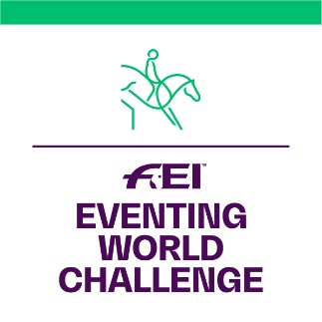

GUIDELINES FOR

“BEST PRESENTATION AWARD”

DURING HORSE INSPECTION

In order to have the same standard when judging the Best Presented Horse at the Veterinary inspection, the Judges and Veterinarians must follow the guidelines given below:

- Is the horse well groomed?
- Is the horse in good physical condition?
- Does the horse stand still during the visual inspection?
- Is the shoeing of the horse in order?
- Has the horse been well trained to walk and trot on a loose rein?
- Is the handler making the turn clockwise?
- Is the handler not trying to shorten the trot by walking an extended distance?
- Is the horse not creating any behavioral problems in the waiting area?
- If passport required, has the passport been approved by the official vet.?
(An FEI passport is not required for FEI Eventing World Challenge competitions).
All horses must be properly registered and identifiable by diagrams.

Please use the score sheet provided for the Presentation (page 2).

Note: It is highly recommended that riders practice trotting their horses prior to the Veterinary inspection in order to avoid accidents and at the same time help better present the horses.

BEST PRESENTED HORSE – SCORE SHEET

FEI EVENTING WORLD CHALLENGE

NF: Location: Date:

Horse’s Name: Passport n° (if required by NF):

Rider’s Name: Handler’s name (if different from Rider):

 | Mark | Score
GROOMING: Cleanliness of the horse; mane and tail brushed and plaited (plaits not required). General tidiness of the horse’s presentation/maintenance (heels trimmed, eyes cleaned, etc.) | 15
PHYSICAL CONDITION: General condition of the horse. Attitude, muscles, coat, eyes and nostrils free of unusual mucus. | 15
BEHAVIOR AT HALT: Horse stands still during the visual inspection. | 15
SHOOING/FEET: Hoofs trimmed correctly; fitting of shoeing; hoofs clean and oiled. | 15
EQUIPMENT: Horse is presented in a bridle which is well maintained. Clean and in a good state. | 10
TRAINING OF THE HORSE FOR THE PRESENTATION: The horse walks and trots on a loose rein without any problem and is attentive to the rider’s/handler’s orders. Well behaved. | 10
TURN: The rider/handler respects the pattern (walk and trot distance respected) as per the FEI Vet Regulations and turns the horse clockwise (without being reminded). | 10
GENERAL BEHAVIOR: The horse is calm and well behaved before, during and after the presentation (waiting area). | 10
TOTAL SCORE | 100
COMMENTS:

SIGNATURES:

President of the Ground Jury Veterinary Delegate

