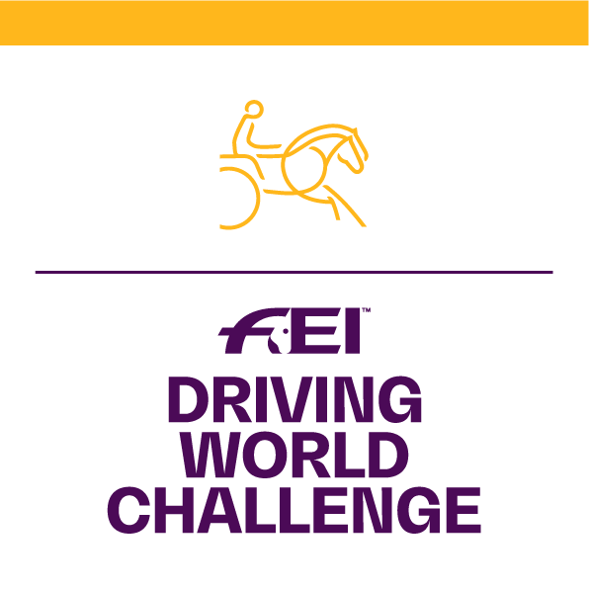

GUIDELINES FOR

“BEST PRESENTATION AWARD”

DURING HORSE INSPECTION

In order to have the same standard when judging the Best Presented Horse at the Veterinary inspection, the Judges and Veterinarians must follow the guidelines given below:

- Is the horse well groomed?
- Is the horse in good physical condition?
- Does the horse stand still during the visual inspection?
- Is the shoeing of the horse in order?
- Has the horse been well trained to walk and trot on a loose rein?
- Is the handler making the turn clockwise?
- Is the handler not trying to shorten the trot by walking an extended distance?
- Is the horse not creating any behavioral problems in the waiting area?
- If passport required, has the passport been approved by the official vet.?
(An FEI passport is not required for FEI Driving World Challenge competitions).
All horses must be properly registered and identifiable by diagrams.

Please use the score sheet provided for the Presentation (page 2).

Note: It is highly recommended that riders practice trotting their horses prior to the Veterinary inspection in order to avoid accidents and at the same time help better present the horses.

BEST PRESENTED HORSE – SCORE SHEET

FEI DRIVING WORLD CHALLENGE

NF: Location: Date:

Horse’s Name: Passport n° (if required by NF):

Athlete’s Name:

 | Mark | Score
GROOMING: Cleanliness of the horse; mane and tail brushed and plaited (plaits not required). General tidiness of the horse’s presentation/maintenance (heels trimmed, eyes cleaned, etc.) | 15
PHYSICAL CONDITION: General condition of the horse. Attitude, muscles, coat, eyes and nostrils free of unusual mucus. | 15
BEHAVIOR AT HALT: Horse stands still during the visual inspection. | 15
SHOOING/FEET: Hoofs trimmed correctly; fitting of shoeing; hoofs clean and oiled. | 15
EQUIPMENT: Horse is presented in harness, which is well maintained. Clean and in a good state. | 10
TRAINING OF THE HORSE FOR THE PRESENTATION: The horse is well behaved and is attentive to the athlete’s orders during the execution of the figure of eight for the Horse Inspection. | 10
FIGURE OF EIGHT: The athlete respects the pattern as per the FEI Driving World Challenge Rules & FEI Vet Regulations (without being reminded). | 10
GENERAL BEHAVIOR: The horse is calm and well behaved before, during and after the presentation (waiting area). | 10
TOTAL SCORE | 100
COMMENTS:

SIGNATURES:

President of the Ground Jury Veterinary Delegate

