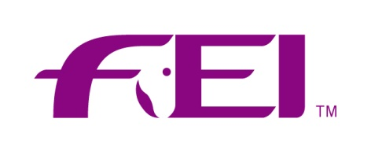
APPLICATION FORM FOR PARTICIPANTS IN
FEI SEMINAR FOR OFFICIALS

DISCIPLINE: REINING

Date of Seminar: |  | Location:

For maintenance of FEI current status
For Registration only

Name: |  | Home Phone:
Date of Birth: |  | Work Phone:
Address: |  | Cell phone:
 |  | Email:
 |  | Fax:
Languages: |  | Other A= spoken
(Mother Tongue) |  | B= understood
 |  | Current FEI Status

Functions fulfilled during the years (CRN/CRI/CRIO)
Year | Place | Event Type  and level judged | Function  (i.e. Member/ President of Ground Jury ; Technical Del.) | Remarks

Courses/Seminars attended
Year | Place | Type | Level | Director's Name

The NF of |  | hereby certifies that the information above regarding the above
Official is correct and true and wish that the official be promoted subject to the recommendation of the Course Director and the Technical Committee.

Signed: |  |  | Date &
NF Official Representative |  |  | Stamp of NF

Course Director:
Name: |  |  | Nationality:

Signed: |  |  | Date:

