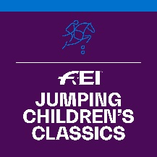

FEI Jumping Children’s Classics 2020

PARTICIPATION FORM

The NF of informs the FEI that it will organise the following FEI Jumping Children’s Classics Competition(s):

Tour | DATES | EVENT SITE
GOLD
SILVER
BRONZE

Please note that Gold Tour Events must take place before 12 October 2020. Silver and Bronze Tour Events must take place before 14 December 2020.

Name of FEI Judge:
(Minimum level 2 Judge from home or abroad)
FEI ID:
Email address of FEI Judge:

Please give the name and contact details of the person to be contacted at your NF in relation to this Competition.

Name:
Position:
Email address:
Phone number:

In my capacity as President of the National Federation, I declare to do my best to ensure that the rules for this Competition are implemented and that the deadlines for returning the results are respected.

Date: NF’s stamp:

Signature: _____________________________

Completed forms to be returned by 30 June 2020 to:

Marijn Dubbeldam, FEI Jumping Department
Email : marijn.dubbeldam@fei.org

