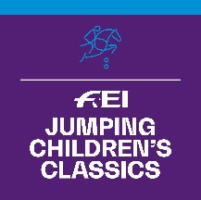
FEI Jumping Children’s Classics 2023

APPLICATION FORM

NATIONAL FEDERATION:

Person responsible to be contacted at your NF in relation to this Competition:
Name:
Position:
Email address:
Phone number:

Informs the FEI that it will organise the FEI Jumping Children’s Classics 2023 in the following Tour(s):

TOUR  (Gold, Silver and/or Bronze) | START DATE  (dd/mm/2023) | END DATE  (dd/mm/2023) | LOCATION  (City, Venue/Club)
GOLD TOUR
SILVER TOUR
BRONZE TOUR

Gold Tour Events must take place by 31 October 2023.
Silver and Bronze Tour Events must take place by 31 December 2023.

FEI Judge (minimum Level 2 from abroad or from the home NF):

Name:
NF:
FEI ID:
Email address:

Applications to be submitted by 30 June 2023 to:

Marijn Dubbeldam, FEI Jumping Department
Email : marijn.dubbeldam@fei.org

Applications received after 30 June 2023 will not be accepted and no additions will be made to the calendar after this date.

Date: Stamp of NF:

Signature: ____________________________

