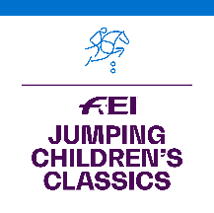
FEI Jumping Children’s Classics 2022

APPLICATION FORM

The National Federation of:

informs the FEI that it will organise the following FEI Jumping Children’s Classics Tour(s):

TOUR | START DATE  (dd/mm/2022) | END DATE  (dd/mm/2022) | LOCATION  (City, Venue/Club)
GOLD TOUR
SILVER TOUR
BRONZE TOUR

Please note that Gold Tour Events must take place by 9 October 2022. Silver and Bronze Tour Events must take place by 11 December 2022.

Name of FEI Judge:
NF:
(Minimum level 2 Judge from home or abroad)
FEI ID:
Email address of FEI Judge:

Please provide the name and contact details of the person to be contacted at your NF in relation to this Competition.

Name:
Position:
Email address:
Phone number:

Date: NF’s stamp:

Signature: _____________________________

Applications to be submitted by 30 June 2022 to:

Marijn Dubbeldam, FEI Jumping Department
Email : marijn.dubbeldam@fei.org

Applications received after 30 June 2022 will not be accepted and no additions will be made to the calendar after this date.

