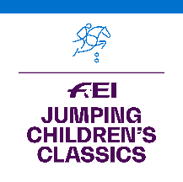
FEI Jumping Children’s Classics 2021

APPLICATION FORM

The National Federation of:

informs the FEI that it will organise the following FEI Jumping Children’s Classics Tour(s):

TOUR | DATES  (dd/mm-dd/mm/2021) | LOCATION  (City, Venue/Club)
GOLD TOUR
SILVER TOUR
BRONZE TOUR

Please note that Gold Tour Events must take place by 10 October 2021. Silver and Bronze Tour Events must take place by 12 December 2021.

Name of FEI Judge:
(Minimum level 2 Judge from home or abroad)
FEI ID:
Email address of FEI Judge:

Please provide the name and contact details of the person to be contacted at your NF in relation to this Competition.

Name:
Position:
Email address:
Phone number:

Date: NF’s stamp:

Signature: _____________________________

Applications to be returned by 30 June 2021 to:

Marijn Dubbeldam, FEI Jumping Department
Email : marijn.dubbeldam@fei.org

Applications received after 30 June 2021 will not be accepted and no additions will be made to the calendar after this date.

