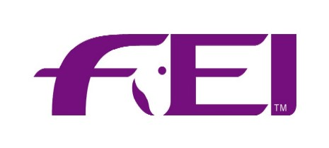

PARA DRESSAGE

PROMOTION/MAINTENANCE APPLICATION FORM FOR PARA DRESSAGE OFFICIALS

COURSE VENUE __________________ DATES __________________

For promotion to/maintenance as:
Para Dressage 3* Judge Status
Para Dressage 4* Judge Status
Para Dressage 5* Judge Status

International Technical Delegate

International Candidate Classifier
International Classifier
Official International Classifier

Para Dressage Steward

Name (capitals) |  | First Name (capitals)
Home phone |  | Work phone
Date of birth |  | Cell phone
Address |  | Email
 |  | Fax
Spoken languages |  | Understood languages
Mother tongue |  | Present status

Please see General Regulations and the Rules for Para Dressage

Functions fulfilled during previous three years
Year | Place | Event Type  and level judged | Function  (i.e. Member/ President of Ground Jury ; Technical Del) | Remarks

Courses attended (past three years)
Year | Place | Type | Course Director's Name

The NF of hereby certifies that the information above regarding the above mentioned Official is correct and true and wishes that the official be promoted subject to the recommendation of the Technical Committee.

NF Official Representative
Stamp and
Date Signature

