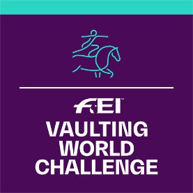
FEI Vaulting World Challenge 2022
Application Form

Please complete this form and return to FEI Solidarity Department, Andreina Wipraechtiger
Fax: +41 21 310 47 60
email: andreina.wipraechtiger@fei.org

DEADLINE 1ST OF DECEMBER 2021

WCHA-V information is available under:
www.inside.fei.org > Vaulting > Main Events >
FEI Vaulting World Challenge

NATIONAL FEDERATION OF:
Person responsible of the organisation of the competition:
Name:
Tel:
Email:

Informs the FEI that it will organise the FEI Vaulting World Challenge 2022:

COMPETITION INFORMATION
Classes Organised |  | Dates | Location | Officials’ Selection
Event 1:  Beginner  Intermediate  Open to Individual only  Open to Individual and Pas-de-Deux  Advanced  Open to Individual only  Open to Individual and Pas-de-Deux |  |  | - City:  - Club: | - Name of PGJ FEI Foreign Judge (“A”): (NF)  - Name of Member of Ground Jury (“C”): (NF)  - Name of FEI Vet Delegate:  (NF)
Event 2 (Optional):  Beginner  Intermediate  Open to Individual only  Open to Individual and Pas-de-Deux  Advanced  Open to Individual only  Open to Individual and Pas-de-Deux |  |  | - City:  - Club: | - Name of PGJ FEI Foreign Judge (“A”): (NF)  - Name of Member of Ground Jury (“C”): (NF)  - Name of FEI Vet Delegate:  (NF)
Note: | For National Federations organising an Equestrian Sport Educative Event in Vaulting and wish to use this opportunity to combine the presence of the FEI Judge delivering the ESEE to the FEI Vaulting World Challenge may do so.  Please check the box if this is the case

Date:
Signature: Stamp of NF:

