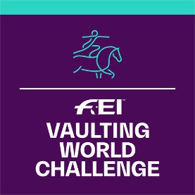
FEI Vaulting World Challenge 2020
Application Form

Please complete this form and return to FEI Solidarity Department, Andreina Wipraechtiger
Fax: +41 21 310 47 60
email: andreina.wipraechtiger@fei.org
Deadline 1st of December 2019

WCHA-V information is available under:
www.inside.fei.org > Vaulting > Main Events >
FEI Vaulting World Challenge

NATIONAL FEDERATION OF:
Person responsible of the organisation of the competition:
Name:
Tel:
Emai:

Informs the FEI that it will organise the FEI Vaulting World Challenge 2020:

The FEI Vaulting World Challenge is, in principle open to nations without any FEI Vaulting calendar or up to one FEI Event a year for countries outside Western Europe – to be discussed if borderline requests.
COMPETITION INFORMATION
Classes Organised | Dates | Location | Officials’ Selection
Event 1:  Beginner  Intermediate  Open to Individual only  Open to Individual and Pas-de-Deux  Advanced  Open to Individual only  Open to Individual and Pas-de-Deux |  | - City:  - Club: | - Name of PGJ FEI Foreign Judge (“A”): (NF)  - Name of Member of Ground Jury (“C”): (NF)  - Name of FEI Vet Delegate:  (NF)
Event 2 (Optional):  Beginner  Intermediate  Open to Individual only  Open to Individual and Pas-de-Deux  Advanced  Open to Individual only  Open to Individual and Pas-de-Deux |  | - City:  - Club: | - Name of PGJ FEI Foreign Judge (“A”): (NF)  - Name of Member of Ground Jury (“C”): (NF)  - Name of FEI Vet Delegate:  (NF)

Date:
Signature: Stamp of NF:

