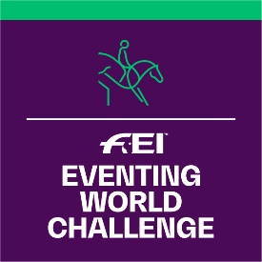
FEI Eventing World Challenge 2023
Application Form

WCHA-C information will be available shortly under:
www.inside.fei.org > Eventing > Main Events >
FEI Eventing World Challenge

Please complete this form and return to FEI Solidarity Department, Andreina Wipraechtiger
Fax: +41 21 310 47 60
email: andreina.wipraechtiger@fei.org

DEADLINE 1ST OF DECEMBER 2022

NATIONAL FEDERATION OF:
Person responsible of the organisation of the competition:
Name:
Tel:
Email:

Informs the FEI that it will organise the FEI Eventing World Challenge 2023:

COMPETITION INFORMATION
Category(ies)  Organised | Date  (dd.mm.2023) | Location | Officials’ Selection  (Name / Nationality / FEI ID if applicable)
CATEGORY A  CATEGORY B  CATEGORY C |  | - City:  - Club: | - President of the Ground Jury*:  - Ground Jury Member*:  - FEI Foreign Technical Delegate (Minimum Level 2 FEI, FEI ID #):  - Eventing Course Designer*:  - FEI Vet Delegate  (Possible derogation for OV in other Discipline, NHV or PTV, FEI ID #):  *NOTE: Please specify if National or FEI

Date:

Signature: Stamp of NF:

