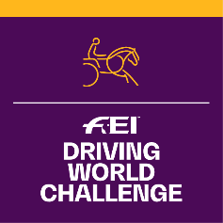
FEI Driving World Challenge 2023
Application Form

Please complete this form and return to FEI Solidarity Department, Andreina Wipraechtiger
Fax: +41 21 310 47 60
email: andreina.wipraechtiger@fei.org
& aude.barby@fei.org

DEADLINE 1ST OF DECEMBER 2022:

WCHA-A information is available under:
www.inside.fei.org > Driving > Main Events >
FEI Driving World Challenge

The deadline is set in accordance with the rules, however for the pilot year an exceptional extension will be given until 1 April for NFs to apply

NATIONAL FEDERATION OF:
Person responsible of the organisation of the competition:
Name:
Tel:
Email:

Informs the FEI that it will organise the FEI Driving World Challenge 2023:

COMPETITION INFORMATION
Categories  Organised | Date (xx.xx.2023) | Location | Officials’ Selection*  Appointed by the FEI & Organising NF in accordance with the WCHA-A rules Art. 6
A  B  C |  | - City:  - Club/Venue: | - Name of Driving FEI or National Experienced Judge:  (NF)  OR  - Name of Driving FEI or National Experienced Course Designer: (NF)  - Name of FEI Vet Delegate:  (NF)
*Note: | Upon receipt of this application within the deadline, the FEI will appoint the FEI official in accordance with the rules article 6.1.  The remaining officials appointed by the NF in accordance to the rules are subject to FEI’s approval.  Late applications may not be acceptable depending on availability of Officials.

Date:
Signature: Stamp of NF:

