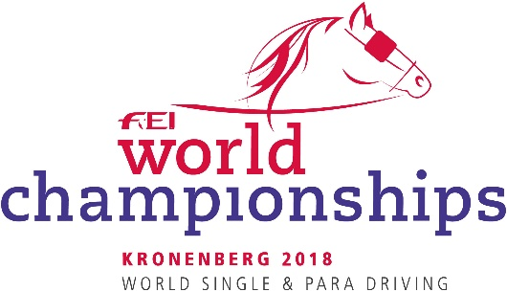
Entry form
FEI World Championships Para Driving
Kronenberg (NED) 28.08-01.09.2018
Updated on 02/07/2018

National Federation:

I, the undersigned, in my capacity as President

Of the National Federation of hereby declare that the hereunder mentioned athletes and horses have the experience and qualifications required to take part in the 2017 FEI World Para-Equestrian Driving Championship for Singles for which they have been entered and that their performances entirely satisfy the standards as laid down in the appropriate FEI Regulations. Please find enclosed the results sheet stating their qualifications. The maximum number of athletes/horses allowed to be listed on these forms (nominated entries) is 6 athletes, 12 horses maximum (2 horses per Driver). If additional Individual entries allowed – TBC with approved schedule.

Athlete  name | Athlete  FEI ID | Date of birth | Gender | Grade  I or II | Horse  name | FEI passport number | Horse or Pony | Bedding

NOTE: Incomplete forms will not be accepted. Must be received by the FEI/OC no later than 31 July 2018.

This list must be signed by the President of the National Federation and returned to the FEI by e-mail: horst@head2tail.nl AND Laurianne.noble@fei.org
Thank you very much!

DATE ....................................................................

SIGNATURE............................................................ NF STAMP

